Task 1:

1)

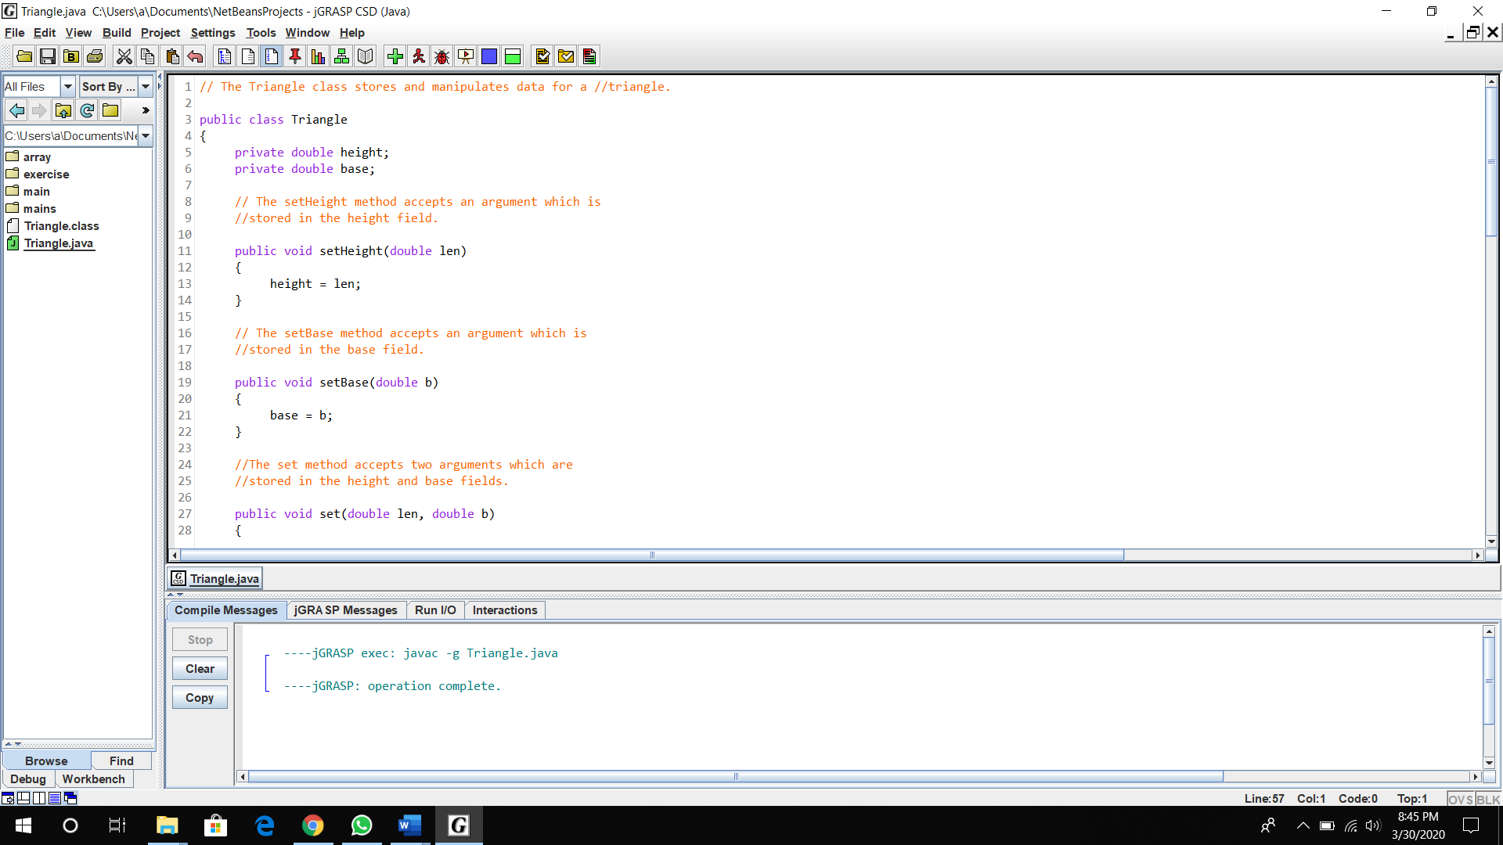

3)



* There is no output
* This is because in the class, there are only constructer to initialize and method to get area or return the value stored.

Task 2:

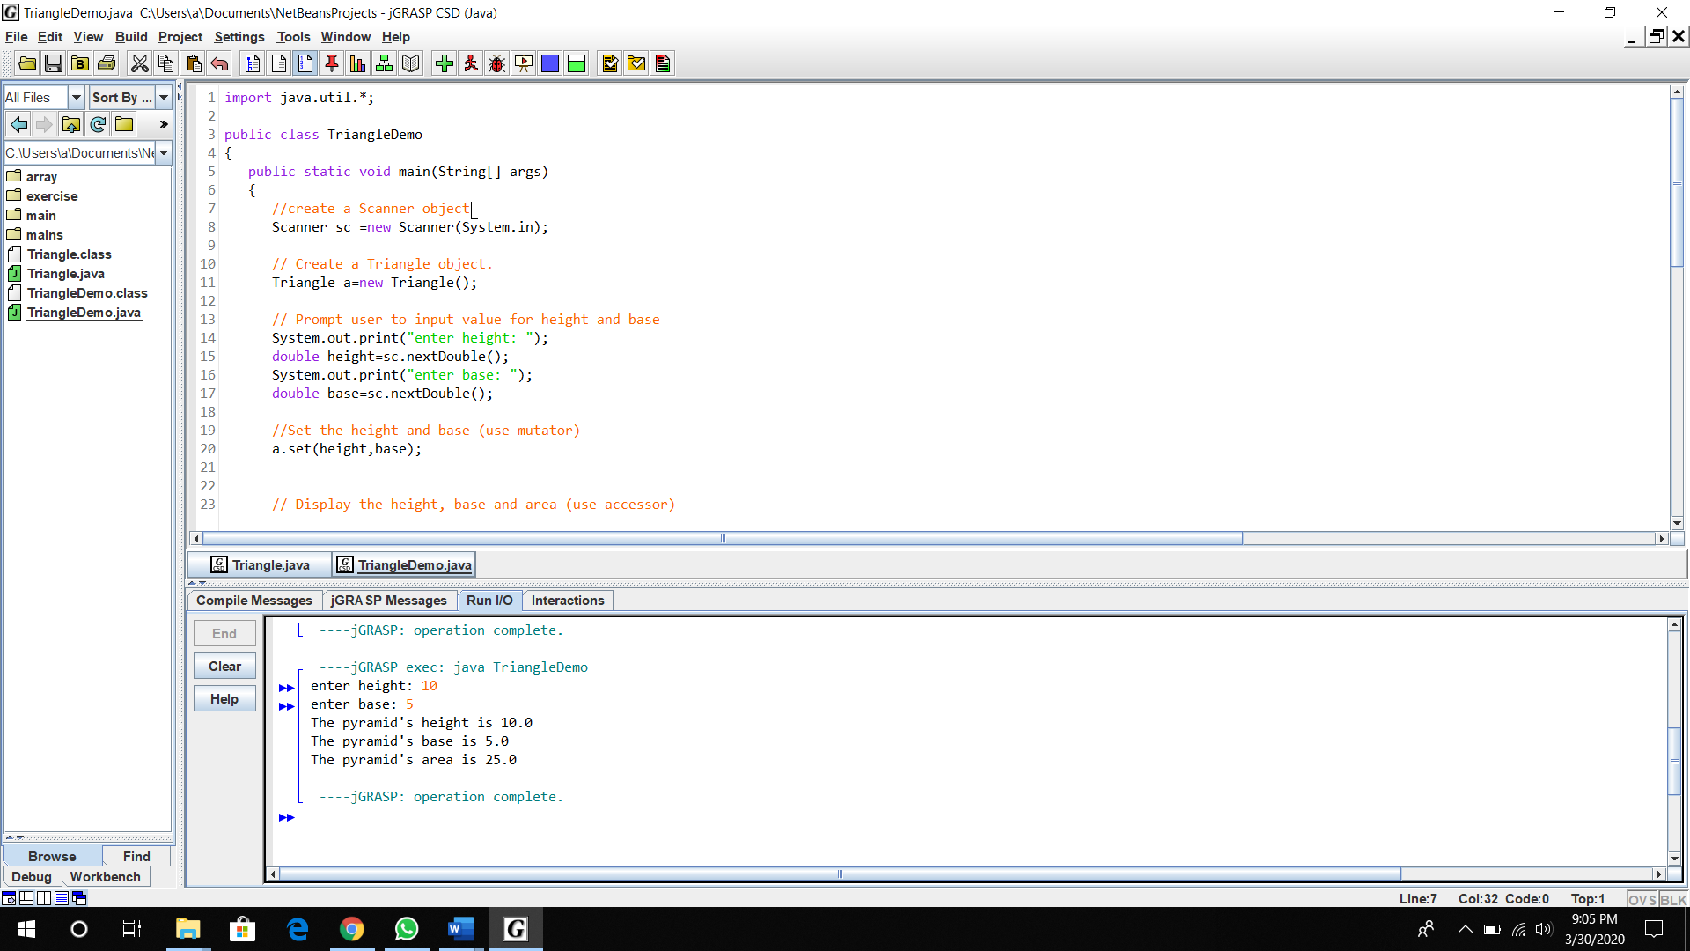

1. Object

-Triangle

1. user-defined methods with return value

- getHeight();

- getBase();

- getArea();

1. user-defined methods with passing-parameters

-setHeight(double len);

-setBase(double b);

- set(double len, double b);

1. accessor methods

- getHeight();

- getBase();

- getArea();

1. mutator methods

-setHeight(double len)

-setBase(double b)

- set(double len, double b)

Task 3:

